1. In the cruising situation, the drag and thrust are balaced perfectly. Now in case, the
thrust is suddenly cut-off, the drag will start reducing the forward speed of the aeroplane
ultimately leading to the stall condition. For extending the Flight time, pilot can try to
decrease the altitude and at the same time, increase the angle of attack on the wings. This
will reduce the Thrust required. The pilot must try to maintain the plane at the minimum drag location in the Thrust required curve.
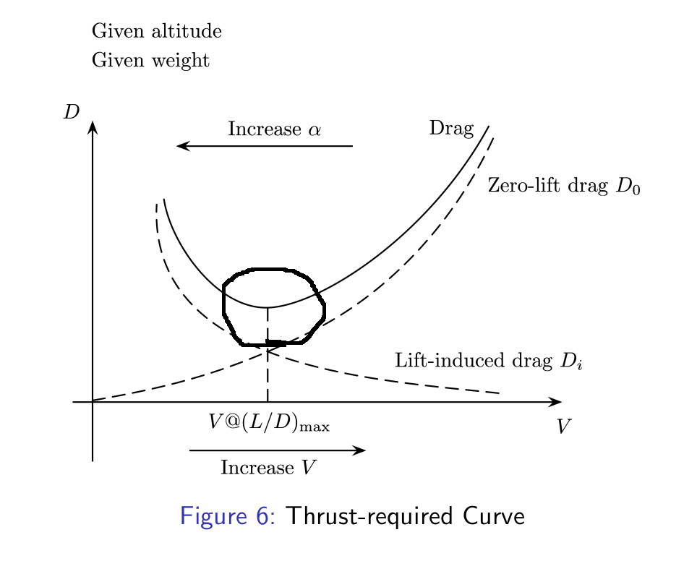
2. Thrust is a function of both the lift and the Drag. Thus, with increase in the velocity, both
the lift and the drag increase, but the term L/D depends on the relative increase. Furthermore, the Lift coefficient and the Drag Coefficient depend on the nagle of attack, which is also function of velocity. As Velocity increases, angle of attack decreases, and thus, Cl decreases. The dynamics of velocity and angle of attack determine the Thrust required.

3. Considering a regular civil flight, with the mission of having the best fuel economy, we choce of propeller becomes a simple question of the power requirements. Now, We need to decide on the pitch and the Diameter of a propeller, keeping in mind that we need to be able to have the required Lift at the cruise speed so as to balance weight. For the given situation, we will further consider the velcoity at which we want the cruising speed. So we start wuth the velocity, decide the L/D for minimum thrust requirements form the plot. Once we have the thrust, we know the requirement of thrust from the propeller. Next, we pickup the APC database and search for propellers of suitable size according to the plane size and manueverability requiremnts. Once we select a few propellers, we calculate the power requirements for each propeller, as performed in the class, and then keep the one with the minimum power requirements.

